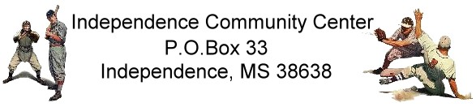
A Non Profit Origination
AGREEMENT FOR TEAM SPONSORSHIP

COMPANY NAME: ________________________________________________

DATE: __________________CONTACT: ______________________________________
PHONE: _________________________________ FAX: ________________________
E-MAIL: ______________________________________________
ADDRESS: _______________________________________________________________
CITY: _______________________________STATE: ____________ZIP: _______________

Sponsorship Fee (Check Preferences): ______ $ 700.00 Sponsor ____ $350.00 Half Sponsor
______ $ 175.00 Fourth Sponsor ________ other

Below $175.00 will be considered donations to be used as needed for the team.

Attach Company/Corporate Logo Art work: (Attach Business Card, if desired)
URL: http://___________________________________________________________________________________
(If you have a web site enter the web address on the line above and we will provide a link to your site)
Full Sponsorship includes: Banner with name & phone number; name on player’s jersey; free ad on our website.
If you are a full sponsor do you want your company name on the uniform shirts ____Yes ____No
Please Make Checks Payable To Independence Community Center.
Office Use:
Division:_____________________ Team Name:_______________________
Manager: _____________________

Amount Collected:

Cash $____________ Check #__________

